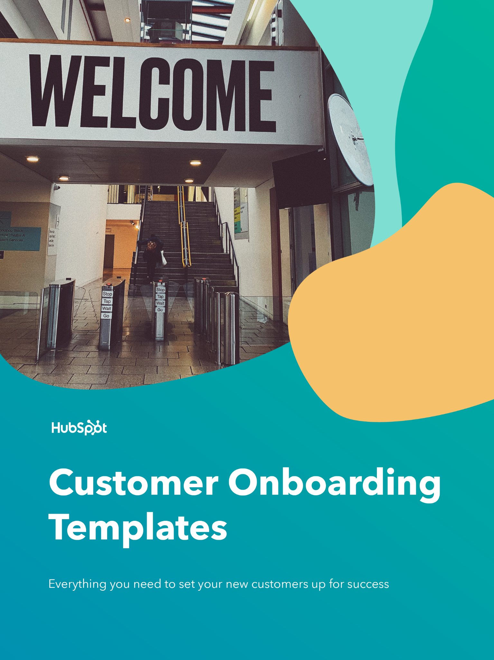

Hi There.

Thanks for Downloading This Resource.

↓↓↓
How to Use This Template
Italicized, grey text indicates that you’re reading instructions for your business. Replace the text with the details relevant to your own business, or, if applicable, delete the instructions after you’ve finished reading them.

Some sections may be more relevant to your business than others. Feel free to take out sections that aren’t relevant to your company along the way.

Internal Onboarding Checklist
New Customer Onboarding Checklist
Welcome
First Onboarding Call Sample Agenda
Training Resources Repository Template
Handoff Templates

Need help onboarding your new customers?  Align your sales, marketing, and customer success teams with HubSpot CRM. | 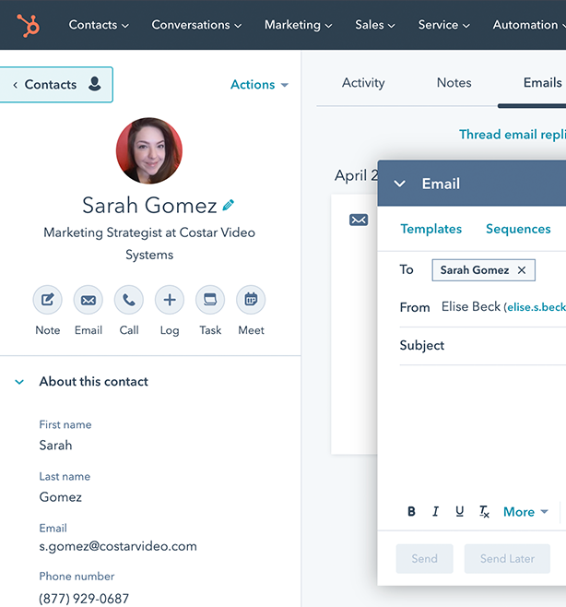
Get HubSpot’s Free CRM

(Keep scrolling to templates)
↓↓↓

Internal Onboarding Checklist

New Customer Onboarding Checklist

[Here, you’ll fill in the action items that your customer success team members or account managers will need to take in order to onboard a new customer. We’ve pre-populated a list of actions, but you’ll need to add, delete, or specify certain items depending upon your company’s product or service.]

Set Up Automation for All New Customers

- Create an automated welcome email that triggers when a new user signs up.
- Schedule a follow-up email to invite your new customer to login to the software that triggers after two days of inactivity.
- Build a greeting message for the initial login that includes a CTA to take their first action.
- Design feature callouts that pop up when a user enters for the first time to help them navigate.
- Create content for all of your empty states (the areas within your product that don’t have content or data in them until the user adds their own).

Tasks to Do Individually for Each New Customer

- Schedule the first meeting between your customer success team and the new customer.
- Prepare welcome packet for the new customer, filling in their specific Customer Success Team members, objectives, and due dates.
- Send over the welcome packet with the due date for the Customer Intake Questionnaire.
- Celebrate once a client hits an early milestone. This could come in the form of an in-app notification, handwritten note, or a small treat delivered to their office.

Welcome

Welcome Packet Template

Welcome to the [Insert Your Company Name] customer community. We’re honored that you’ve chosen to work with us. It’s our utmost priority to ensure you have an excellent experience with our [product/service] and team from day one, so we’ve compiled this packet of resources to provide a framework and clear path for success in the first [Insert onboarding time frame] and beyond.

Inside this packet, you’ll find:

[Delete components that are not necessary for your company’s onboarding process and add any that we’ve missed.]

- An introduction to our team and your points of contact at [Insert Your Company Name]
- A customer intake form (Please return this to us by [insert due date].)
- A timeline for our first [Insert time frame] months together
- Links to help documentation and other resources

Meet Your Team

Below, you’ll find your key points of contact at [Insert Your Company Name].

[Replace the stock silhouettes with friendly headshots of your customer success team members who will be responsible for this customer.]

[Insert Name of Team Member & Title] | [Insert Name of Team Member & Title] | [Insert Name of Team Member & Title]
[Insert Email Address & Phone] | [Insert Email Address & Phone] | [Insert Email Address & Phone]

Customer Intake Form Template

Customer Intake Questionnaire: [Insert Customer Name Here]
Please return by [Insert Due Date]

Please return this form back to us by [Insert Due Date]. We’ll review your answers together on your first call on [Insert Date/Time of First Call].

Company Fundamentals & Contacts

- Explain your brand or organization in several sentences. Please describe the core products or services you provide.

- How many employees do you have?

- How many employees do you expect will be interfacing with [Insert Your Company Name]? Please provide a list of the key team members who you expect will be meeting with us on a regular basis and their email addresses.

Company & Team Objectives

- What are your company’s key goals? In other words, how does your company define its success?

- What are your team’s key goals?

- [If applicable for services work] What is your team’s budget?

Challenges

- Who are your biggest competitors?

- What are the top three obstacles your company faces?

Previous Setup

- Prior to signing on with us, how was your team [Insert key activities that your product/service enables -- e.g. “approaching paid advertising” or “generating new leads every month”]?

[Note: The following questions in the ‘Previous Setup’ section are primarily applicable for companies that provide software and other technology products. Feel free to delete the questions if you provide a different type of product or service.]

- Please describe your current technology stack, mentioning any tools you use that our product will replace.

- Will you need assistance migrating data or system settings from your previous system to ours? If so, what is your budget for technical assistance?

- If you have an in-house team that will be handling the migration, please provide the best point of contact on that team and their email address.

Expectations

- What are you hoping to achieve by working with [Insert Your Company Name]? List any goals that come to mind.

- Why did you choose us over other [product/service] providers?

Onboarding Timeline Template

Instructions:
- In the table below, outline the onboarding process for your new customer.
- In the “Date to Complete” column, include a date by which you want them to have a certain onboarding call, complete a training, finish IT setup, or use a certain feature of your product.
- Describe the activity or the content of the call in the middle column so that the customer understands what they need to do on or before that date.
- Set objectives so that it’s clear what successful onboarding looks like. By setting objectives, your new customers will find satisfaction in checking items off. Better yet, they’ll be interfacing with your product or service regularly as soon as they buy -- which is great for retention.

Below, you’ll find a schedule of our time together during the onboarding phase.

Onboarding with [Insert Your Company/Product Name]
- Write the length of onboarding here -- e.g. “6 weeks”
- Write the date range here -- e.g. “Runs from January 1, YYYY to February 13, YYYY”
- Add any important details around the cadence of onboarding calls, when the customer can expect to hear from you,

Schedule

Here’s a detailed outline of what we’ll be covering in onboarding, from our calls together to the early steps you and your team will take to get up and running with [Insert Your Company/Product Name].

We can schedule our calls together sooner than the dates that they’re due -- these are simply guidelines to ensure that we have enough time to get through everything we need to in the next [Insert Length of Onboarding].

You can also feel free to complete the tasks ahead of time.

Date to Complete | Meeting/Task/Training | Objective(s)
EXAMPLE  Jan. 9 | EXAMPLE  First Onboarding Call | EXAMPLE  - Meet our team  - Go over onboarding schedule  - Define onboarding goals
EXAMPLE  Jan. 18 | EXAMPLE  Product Training Call  ** Please review this resource before the call. ** | EXAMPLE  - Create a new contact  - Review import process  - Set up deal pipeline in settings
EXAMPLE  Feb. 20 | EXAMPLE  Import all data from previous system  - Note: Contact our Support team if you run into any challenges along the way! | EXAMPLE  - All data migrated to our product

First Onboarding Call Sample Agenda

This sample agenda is intended to serve as a starting point for a standardized onboarding call agenda that all of your customer success team members can use.

Swap out items on this list where it makes sense for you, your team, or your product/service.

Who’s Involved?

[Insert Your Company Name]:
- List your team members who need to be on the call.

[Insert Customer Name]:
- List the customers who need to be included on the call.
- If you don’t know the names of the people who need to be on the call yet, specify their titles -- e.g. “A representative from your IT team”

Agenda

**Double-check to make sure that all parties are present on the call before beginning.**

- Introductions
  - Introduce yourself
  - Ask every person on the call to introduce themselves and describe their role. Make note of each participant’s location, too.
  - Build rapport
- Onboarding Overview
  - Set expectations around timeline and goals
    - Mention the Customer Intake Questionnaire and its due date
  - Explain your role as Customer Success Manager/Onboarding Specialist
- Overview of Product/Service Resources
  - Explain where the customer can go to get help
  - Show them any help documentation you have available
  - Share the resources portion of the Welcome Packet with them
- Customer Processes/Goals
  - Ask about the customer’s business goals (if B2B) or their personal goals (if B2C)
  - Get an overview of the processes they’re currently using to do what your product/service will do
    - Take note of what motivates them
    - Review the notes that your Sales team left on their purchasing decision
    - What results do they want to see with your product/service?
  - Set goals
    - Review the trainings and actions they’ll need to complete by the end of onboarding in order to start seeing results with your product/service
    - Run through suggested timeline, walking through Timeline section of Welcome Packet
- Next Steps
  - Review and assign the tasks and trainings
  - Schedule the next call

Training Resources Repository Template

This template is intended to help you share any important resources with your new customer. This is where you can go into detail on the trainings that your customer will have to complete, link out to help documents that they’ll need to read to set and start using the product, and how they can get help if they’ve gone through all of the listed resources.

Trainings to Complete:
- Here, list any product training sessions, webinar recordings, or videos that your new customer should watch to familiarize themselves with the product/service or your company.
- Include the due date if applicable.
- Be sure to link out to the resource to that the customer is able to access everything they need from one centralized document.
- EXAMPLE: “Content Marketing Certification (by January 15th)”

Help Documentation:
- Link out to key setup or onboarding documentation.
- Provide the name of the article and then hyperlink the text to make it clear what the customer will be reading.
- EXAMPLE: “How to import contacts, companies, deals, tickets, products, or notes”

How to Reach Customer Support:

Customer Support will be your best resource for [Insert the kinds of issues that Support is most qualified to handle rather than you, the Customer Success Manager]. For other inquiries, feel free to reach out to me at [Insert your email address here].

Support Email Address: [Insert Support email address]
Support Phone Number: [Insert Support phone line and extension if applicable]
Support Hours: [Insert hours, including time zone]

Handoff Templates

Handoff Email Template

If your team has onboarding specialists who pass on the service role to a different long-term account manager or team once onboarding is complete, consider adapting the following email to alert the customer that the onboarding period is ending.

If you choose to write your own handoff email, be sure to include the following elements:
- New point of contact (POC) at your company and their contact information
- What topics or issues the new POC at your company can address
- How the customer can reach out to your team for support or set up a meeting

Hi [Insert Contact Name],

We've come to the end of onboarding, and it's time to transition to your long-term point of contact at [Insert Your Company’s Name], [Insert name of new POC or support team] (cc'd). [New POC or team] will ensure you're maximizing the value you see with [Insert product/service name] while providing guidance on your long-term strategy and use of [Insert names of any tools your success team will help customers use]. They also serve as account managers and can address any account or contract questions you may have.

I've documented our work together to date, and I'd encourage you to reach out to them directly if you have any questions or topics you would like to cover. You can also contact our Customer Support team at [Insert phone number].

It's been a pleasure working with you and I wish you the best!

Sincerely,
[Your Name]

Handoff Notes Template

Your early customer interactions are crucial for your customers’ long-term success with your product or service. We always recommend documenting how the customer’s team is doing with the product/service at the end of onboarding to give customer service folks, renewal specialists, and long-term account managers a clear picture of each customer’s history and goals.

We’ve created this notes template to ensure you don’t miss any important information. Please note that this template is most applicable for B2B businesses, so you may need to take a different approach if you work for a B2C business.

Team:
Main Contacts/Location:
- List the main POC first, including the best way to reach them and their office location.
- List other POCs below them, specifying their roles and situations they’d want to be looped into.
- Make sure to be specific about location if it differs across the team.

Decision Maker:
- Specify the decision maker here. This might be a VP or other more senior employee who’s not dealing with your product or service day to day, but who tends to have decision-making power in cases related to your product/service.

Company:
Summary of what company does:
- Describe the core product or service that the customer’s business supplies.
- Any relevant details about company structure may be useful here, too.

How they make money:
- This may be obvious in some cases, but it’s still worth listing the customer’s revenue sources to see where leadership’s priorities are.

Execution:
Highlights/Goals Reached:
- List the goals that the customer accomplished during the onboarding period.
- These may be product usage goals, training sessions completed, or results they’ve already noticed during onboarding.
- Note the highlights for the customer, too. What was most exciting for them to accomplish?

Challenges:
- What roadblocks is the customer still facing?
- In which skill areas does the customer tend to need extra help?
- What larger challenges does the customer’s business/individual customer face that may impact the ability to be successful with our product/service?

Remaining items to address:
- Is there anything that the customer specified they wanted to address on future calls?
- Was there something they mentioned they wanted to start doing eventually, after they’d fully ramped onto the product/service?

Additional Services/Product/Training Needed:
- Here, specify any training sessions that the customer has yet to complete.
- You can also recommend additional resources that the new account manager could send along.

Did We Miss Something?

Add another section here if you need it.

